**TABLE OF CONTENTS**

|  |  |  |
| --- | --- | --- |
| **CHAPTER NO** | **CONTENTS** | **PAGE NO** |
| **1** | **INTRODUCTION** | 1 |
| 1.1 ORGANISATION PROFILE | 1 |
| 1.2 SYSTEM SPECIFICATION | 3 |
| 1.2.1 HARDWARE CONFIGURATION | 3 |
| 1.2.2 SOFTWARE SPECIFICATION | 3 |
| **2** | **SYSTEM STUDY** | 4 |
| 2.1 EXISTING SYSTEM | 4 |
| 2.1.1 DRAWBACKS | 4 |
| 2.2 PROPOSED SYSTEM | 5 |
| 2.2.1 ADVANTAGES OF PROPOSED SYSTEM | 5 |
| **3** | **SYSTEM DESIGN AND DEVELOPMENT** | 6 |
| 3.1 INPUT DESIGN | 6 |
| 3.2 OUTPUT DESIGN | 7 |
| 3.3 DATABASE DESIGN | 7 |
| 3.4 SYSTEM DEVELOPMENT | 8 |
| 3.4.1 DESCRIPTION OF MODULES | 8 |
| **4** | **TESTING AND IMPLEMENTATION** | 15 |
| **5** | **CONCLUSION** | 27 |
| **6** | **BIBLIOGRAPHY** | 28 |
|  | **APPENDICES** | 29 |
| 1. DATA FLOW DIAGRAM | 29 |
| 1. TABLE STRUCTURE | 30 |
| 1. SAMPLE CODING | 35 |
| 1. SCREEN LAYOUT | 54 |

**QR CODE BASED HALL TICKET**

**SYNOPSIS**

The project entitled as **“QR Code Based Hall ticket System for Students”** has developed using PHP as front end and My SQL server as back end. This project is being created to decrease the effort of human and forgery in hall tickets in the educational institutes. The hall ticket is fully based on the Quick Response(QR) code, which is a new embedding technique. This project is the pure automated solution and it will help to generate student hall ticket easily. It is a special type of software which will be used to make a secure hall ticket with QR code instead of the bar code

In current scenario, educational institutes have different types of examinations. For all these they need to distribute hall ticket. In the existing system, there are printed hall tickets are used. So any one can forge and make malpractice over the printed copies. The main aim of this project to generate unique QR code for students’ hall tickets. This helps to keep the data secret. Using the QR reader/scanner the hall ticket information’s can be extracted. Using this application, the admin can generate hall ticket for individual students; this will be transferred via email.

The students can take printout of these QR codes at the time of examination. In this automated system the hall ticket and results data generation process is completely done by the computer with the help of the software.

**CHAPTER 1**

**INTRODUCTION**

QR code (Quick Response Code) is said to be the two dimensional bar code (2D) and it is a special type of matrix barcode which was made for the auto motive factories purpose.

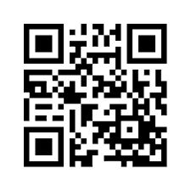

**Sample QR code**

Advantages of QR code when it is online then it can read anything and all is done with the help of the camera and sensor of the cell phone. With a QR reader such as QR reader the QR code can easily give the link of the details of the product. One can easily download the QR code reader by downloading it from online and it is totally free. Camera needs not to be lined-up to read the QR code in a particular way. People may think that the scanner must have to be lined up rightly.

Using the above QR code technique, the hall ticket and result information’s are generated. The information of the students is stored in the database by the administration. As a result there is no time delay for data manipulating and storing is suitable for the whole process. The proposed project will have picture capturing facility which is a great advantage as most of the hall ticket has. Using the QR code will allow to reduce make fake hall ticket.

**1.2.** **SYSTEM specification**

**1.2.1. Hardware Requirements**

Processor : Pentium IV 2.4 GHz.

RAM : 256 MB

Cache Memory : 512 KB

Floppy Disk Drive : 1.44 MB

Hard Disk Drive : 40 GB

Keyboard : Windows Keyboard.

Mouse : Logitech 2 Button Mouse with Scroll key

Monitor : Color Monitor with refresh rate of 85 Hz

**1.2.2. Software Requirements**

Operating System : Windows 7

Front End : PHP 5.0

Back End : MYSQL 4.0

**SOFTWARE REQUIREMNTS**

**Overview of PHP 5.0**

PHP (acronym for: PHP Hypertext Preprocessor), is a server-side embedded scripting language. Thismeans that it works within an HTML document to confer to it the capacity of generating content ondemand. You can convert your site into a web application, not just a collection of static pages withinformation that may not get updated quite so often, which may be alright for a "personal" web site.

PHP is the widely-used, free, and efficient alternative to competitors such as Microsoft's ASP. PHP is perfectly suited for Web development and can be embedded directly into the HTML code.

The PHP syntax is very similar to Perl and C. PHP is often used together with Apache (web server) on various operating systems. It also supports ISAPI and can be used with Microsoft's IIS on Windows.

A PHP file may contain text, HTML tags and scripts. Scripts in a PHP file are executed on the server. Of course general scripting or programming languages like Perl, Python, etc. have also platform independence, and are open source.

PHP was designed to work on the web, and in this ambit it excels connecting and querying a database is a simple task that can be handled in 2 or 3 lines of code. The PHP scripting engine is well optimized for the response times needed on web applications it can even be part of the web server itself improving the throughput even more.

The PHP language features the usual complement of control structures, operators, variable types, function declarations and class/object declarations that we have been accustomed to expect from any compiled or interpreted language, and yet it also has features of its own. For example, in C you employ pointers, in other scripting languages this can be cumbersome or even not possible, but in PHP this is just one use of variable variables.

PHP comes with a myriad of options, both to build the distribution and also to configure an installation. PHP supports several APIs and interfaces to other programming tools .The sheer number of these tools is daunting, not to speak of the configuration possibilities for each of these.

Before we get involved in the detail of installing PHP, it would be worthwhile to consider what we would expect to do with PHP in the near future. Depending on this we need to include only those particular modules that are germane to the kind of stuff we plan to do with the installation.

**Platforms and Web Servers**

PHP is supported on quite a few platforms, many of them UNIX-like and of course on Microsoft’s operating systems supporting the Win32 environment. Since PHP cannot do much without a web server, when we talk of installing PHP on a platform, we also need to take into consideration the web server that we plan to use.



**1.3.4 Back-End Tool with Version**

**MY-SQL 4.0**

MySQL is a full-featured relational database management system. It is very stable and has proven itself over time. MySQL has been in production for over 10 years. MySQL is a multithreaded server. *Multithreaded* means that every time someone establishes a connection with the server, the server program creates a thread or process to handle that client's requests. This makes for an extremely fast server. In effect, every client who connects to a MySQL server gets his or her own thread.

Yet another feature of MySQL is its portability—it has been ported to almost every platform. This means that you don't have to change your main platform to take advantage of MySQL. And if you do want to switch, there is probably a MySQL port for your new platform.

MySQL also has many different application programming interfaces (APIs). They include APIs for Perl, TCL, Python, C/C++, Java (JDBC), and ODBC. So no matter what your company's expertise is, MySQL has a way for you to access it.

MySQL is also very cheap. For an unlicensed, full version of MySQL, the cost is nothing. To license your copy will currently cost you $200. This is an incredible deal, considering what you are getting for your money.

Database systems that provide half the features that MySQL has can cost tens of thousands of dollars. MySQL can do what they do better and for less.

MySQL is a relational database. It uses tables and columns to hold data that can be related by keys. It is well suited for this role. It is also very well suited for various architectures. It can be used in a strictly client/server architecture or as a standalone database.

**The MySQL Supported Types**

MySQL has various data types that support different functions. A data typeis the type of data a column will store. There can be many different data types inside a table, but each column will store its own specific type of information. You can think of a data type as a kind of definition for a column.

A column defined as an integer column will only hold numeric information, whereas a column defined as a CHAR(10) will hold up to 10 alphanumeric characters. These definitions are the key to a quick and efficient database. There are basically three groups of data formats. The first is obviously numeric. Numeric data is data that is a positive or negative number such as 4 or -50.

Numeric data can also be in hexadecimal format (2ee250cc), scientific notation (2X10^23), or a decimal. The second type is character or string format. This format can consist of letters and numbers, whole words, addresses, phone numbers, and generally anything you have to put quotations around.

It consists of everything that doesn't quite fit into either of the other two categories. Some, like dates and times, could be alphanumeric but are stored like numbers. As well as data types, MySQL also provides column modifiers. These modifiers further help define a column's attributes.

They are AUTO_INCREMENT, UNSIGNED, PRIMARY KEY, NULL, NOT NULL, and BINARY. A more detailed discussion of column modifiers takes place following the coverage of the basic data types.

MySQL runs on many platforms, and binaries are available for most of them. Binaries are the result of compiling the source code. This is by far the easiest way of acquiring MySQL. The alternative is downloading the source code for your platform and then compiling it.

MySQL has many utilities to import as well as export data. It shares some of the common options, but this utility does a little more. It takes the entire database and dumps it into a single text file.

This file contains all the SQL commands needed to recreate your database. It takes the schema and converts it to the proper DDL syntax (**CREATE** statements), and it takes all the data and creates **INSERT** statements out of them. This utility reverse engineers your database.

**Hyper Text Markup Language (HTML)**

HTML stands for Hyper Text Markup Language. Hypertext is ordinary text that has been dressed up with extra features, such as formatting, images, multimedia, and links to other documents. Mark up is the process of taking ordinary text and adding extra symbols. Language is actually a key point to remember about HTML. HTML is a universal language for classifying the function of different sections of a document. It is neither a page-layout language nor a printing language. This allows documents to be displayed on many different kinds of platforms. HTML is flexible to work on the website with their variety of commands.

As a formatting language, HTML utilizes SGML (Standard General Markup Language) and Document Type Declarations (DTD). SGML document has three main parts. The first part defines the character set to be used and tells which character i that set distinguishes text for markup tags. Markup tags specify how the viewer application or browser should present the text to the user.

The second part specifies the document and states which markup tags are legal. The third part called the document instance contains the actual text and markup tags. Because there is no requirement that the three parts of an SGML document reside in the same physical file, we can concentrate on the document instance. The web pages created are document instances.

**CHAPTER 2**

**system analysis**

**2.1. existing system**

Students have to carry the hardcopy or softcopy of the hall ticket to make authenticate in exam hall or anywhere. Barcodes are often intended for use where using a barcode device, a consumer can take an image of a barcode on a product and this is not for hall ticket and so and so.

**2.1.1. LIMITATUIONS OF EXISTING SYSTEM**

* System software failure may cost more delays and a light beam might be refracted by water particles suspended in the atmosphere, resulting in focus distortion.
* In laser scanning, durability and cost are the two disadvantages and a barcode becomes scratched or crumpled the reader may not be able to read it.
* If the scan rate of a reader is exceeded by the speed of movement of the bar codes, a loss of reading accuracy, together with failure to read a bar code
* A bar code reader cannot read a bar code if there is any obstacle between the reader and the bar code.

**2.2. Proposed System**

QR hall ticket generation system using Multiplexing and De-multiplexing algorithm for recognizes. QR code image using smart phones to provide various services that can recognize the authenticity of anything.

So QR code verifies by capturing it through the smart phone, then decodes and sends it to the server for authentication.

**2.2.1. FEATURES OF PROPOSED SYSTEM**

* Students need not to carry hall ticket and need not to worry if it is lost.
* A simple scan captures the desired information.
* The Decoded data can be stored in the server and can be viewed by anyone.
* High accuracy in image capturing
* Students can easily detect the QR code image, via his Android mobile itself.

**3. SYSTEM DESIGN AND DEVELOPMENT**

**3.1. INPUT DESIGN**

The input design is the process of entering data to the system. The input design goal is to enter to the computer as accurate as possible. Here inputs are designed effectively so that errors made by the operations are minimized. The inputs to the system have been designed in such a way that manual forms and the inputs are coordinated where the data elements are common to the source document and to the input. The input is acceptable and understandable by the users who are using it.

Input design is the process of converting user-originated inputs to a computer-based format input data are collected and organized into group of similar data. Once identified, appropriate input media are selected for processing. The input design also determines the user to interact efficiently with the system. Input design is a part of overall system design that requires special attention because it is the common source for data processing error. The goal of designing input data is to make entry easy and free from errors.

Input design is the process of connecting the user-originated inputs into a computer to used format. The goal of the input design is to make the data entry logical & free from errors. Errors in the input database controlled by input design. This application is being developed in a user-friendly manner. The forms are being designed in such a way that during the processing the cursor is placed in the position where the data must be entered. An option of selecting an appropriate input from the values of validation is made for each of every data entered. Help managers are also provided whenever the user entry to a new field to that he/she can understand what is to be entered. Whenever the user enter an error data, error manager displayed user can move to next field only after entering the correct data.

**3.2. OUTPUT DESIGN**

Output design is the process of converting computer data into hard copy that is understood by all. The various outputs have been designed in such a way that they represent the same format that the office and management used to. Computer output is the most important and direct source of information to the user. Efficient, intelligible output design should improve the systems relationships with the user and help in decision making. A major form of output is the hardcopy from the printer.

Output requirements are designed during system analysis. A good starting point for the output design is the Data Flow Diagram (DFD). Human factors educe issues for design involves addressing internal controls to ensure readability. The output form in the system is either by screen or by hard copies. Output design aims at communicating the results of the processing of the users. The reports are generated to suit the needs of the users. The reports have to be generated with appropriate levels.

**3.3. DATABASE DESIGN**

The most important consideration in designing the database is how information will be used.

The main objectives of designing a database are:

**Data Integration**

In a database, information from several files are coordinated, accessed and operated upon as through it is in a single file. Logically, the information are centralized, physically, the data may be located on different devices, connected through data communication facilities.

**Data Integrity**

Data integrity means storing all data in one place only and how each application to access it. This approach results in more consistent information, one update being sufficient to achieve a new record status for all applications, which use it. This leads to less data redundancy; data items need not be duplicated; a reduction in the direct access storage requirement.

**Data Independence**

Data independence is the insulation of application programs from changing aspects of physical data organization. This objective seeks to allow changes in the content and organization of physical data without reprogramming of applications and to allow modifications to application programs without reorganizing the physical data.

The tables needed for each module were designed and the specification of each and every column was given based on the records and details collected during record specification of the system study.

**3.4. SYSTEM DEVELOPMENT**

The key to control maintenance costs is to design systems that are easy to change, so the link between development and maintenance is very strong. Many of the analysis and design methodologies, tools, and techniques employed during system development can be applied to system maintenance, but there are significant differences between development and maintenance. Maintainability is the ease with which software can be understood, corrected, adopted and enhanced.

**3.4.1. DESCRIPTION OF MODULES**

* **QR Code Structured Defining**
* **Admin**
* **Exam details**
* **Candidate registration**
* **Hall ticket details**
* **QR Code Generation**
* **Report**

**MODULE DESCRIPTION**

**QR Code Structure defining**

The Structure and version for the hall ticket will be defined in this module. The Different types of versions are differing from the storage capacity.

The image below demonstrates all of the required sections of data modules, rendered in the QR Code. Each colorized section includes a description for its purpose in the final QR code rendering. Each one of these segments is obligatory, with the exception of “format information”, which is introduced in version 7 and up. There are two types of such data. One is the “format data”, which are modules such as the “alignment detection”, as well as “position detection”. These are important in allowing the decoder to know which version the code is, and what error correction level it has. The other type of data is the actual data being encoded. It is always complemented by the error correction bytes. These ensure that the QR code will be read successfully if portion if it is damaged.

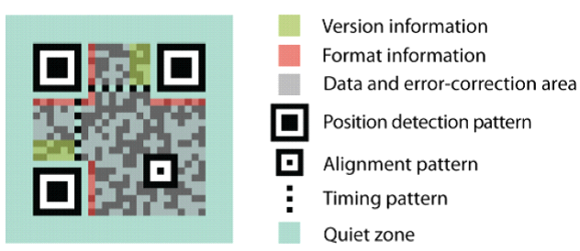

The Structure and version for the hall ticket will be defined in this module. The Different types of versions are differing from the storage capacity.

**Admin Module**

Administrator is only having the full control of this website who are responsible to post the exam details such that what are the exams and which date it is commenced. As well as they can verify the registered application and issue the hall ticket

**Exam Details**

This exam details module contains the complete exam details for the candidates. It contains the fields like student id, date of examination, examination subject, terminal examination, monthly examination, examination marks and grade of student.

**Student Registration**

This student registration module is used for doing student exam application registration. From this module we can retrieve the student’s complete personal and official information through the student registration number for the other modules.

**Hall ticket details**

This module is used to post the hall ticket for each candidate by the administrator. It also used to collect the respective hall ticket by the candidate through their token verification and login process.

**QR code Generation process**

Admin is the authority to generate the QR code for hall ticket to all the students who are appearing for the examination. Admin generate QR code for all the students and stores the QR Images with the registration Id and send those Images to the corresponding student email id.

**QR Scanning**

Using the QR reader/scanner the hall ticket and mark information’s can be extracted. The Scanned information that is the hall ticket information will be displayed as a result. The scanner can be able to read the distorted QR code images too.

**CHAPTER 4**

**SYSTEM TESTING AND IMPLEMENTATION**

**4.1 SYSTEM TESTING**

System testing is the process of exercising software with the intent of finding and ultimately correcting errors. This fundamental philosophy does not change for web applications, because Web-based systems and application reside on a network and interoperate with many different operating system, browsers, hardware platforms, and communication protocols; the search for errors represents a significant challenge for web application.

The distributed nature of client\server environments, the performance issues associated with transaction processing, the potential presence of a number of different hardware platforms, the complexities of network communication, the need to serve multiple clients from a centralized database and the requirements imposed on the server all combine to make testing of client\server architectures.

System testing is actually a series of different tests whose primary purpose is to fully exercise the computer based system. System testing is the state of implementation that is aimed at assuring that the system works accurately and efficiently. Testing is the vital to the success of the system. System testing makes the logical assumption that if all the parts of the system are correct, the goal will be successfully achieved.

**The objective of testing is as follows:**

* + Testing is the process of executing a program with the intent of finding an error.
  + A successful test is that one of the cover of undiscovered error.

### TESTING ISSUES

* Client GUI considerations
* Target environment and platform diversity considerations
* Distributed database considerations
* Distributed processing considerations

**TESTING METHODOLOGIES**

System testing is state of implementation, which is aimed at ensuring that the system works accurately and efficiently as expect before live operation commences. It certifies that the whole set of programs hang together.

System testing requires a test plan that consists of several key activities and step for run program, string, system and user acceptance testing. The implementation of newly designed package is important in adopting a successful new system

Testing is the important stage in software development. the system test in implementation stage in software development process. The system testing implementation should be confirmation that all is correct and an opportunity to show the users that the system works as expected. It accounts the largest percentage of technical effort in the software development process.

Testing phase in the development cycle validates the code against the functional specification testing is vital to achievement of the system goals. The objective of the testing is to discover errors to fulfills this objective a series of test step unit, integration. Validation and system tests were planned and executed the test steps are:

**System Testing**

Testing is an important phase in project development. System testing makes a logical assumption that if all parts of the system are correct, and the goal will be achieved successfully. The software must meet the user specification and it must satisfy according to the needs of the users.

Testing is the process of executing a project within the intend of finding errors. A good test case is one that has a high probability of finding an undiscovered error.

**Unit Testing**

Unit testing focuses verification efforts on the smallest unit of software design of the module. This is also known as “module testing”. This testing is carried out during programming stage itself. In this testing step, each module is found to be working satisfactorily as regards to the expected output of the modules.

**Integration Testing**

Data can be lost across an interface, one module can have adverse effect on another sub function when combined it may not produce the desired major functions. Integration testing is a systematic testing for constructing test to uncover errors associated within an interface.

The objectives taken from unit tested modules and a program structure is built for integrated testing. All the modules are combined and the test is made.

A correction made in this testing is difficult because the vast expenses of the entire program complicated the isolation of causes. In this integration testing step, all the errors are corrected for next testing process.

**Validation Testing**

After the completion of the integrated testing, software is completely assembled as a package; interfacing error has been uncovered and corrected and a final series of software test validation begins.

Validation testing can be defined in many ways but a simple definition is that validation succeeds when the software function in a manner that can be reasonably expected by the customer. After validation test has been conducted, one of two possible conditions exists:

**Output Testing**

The next process of validation testing, is output testing of the proposed system, since no system could be successful if it does not produce the required output in the specified format. Asking the user about the format required, list the output to be generated or displayed by the system under considerations.

Output testing is a different test whose primary purpose is to fully exercise the computer based system although each test has a different purpose all the work should verify that all system elements have been properly integrated and perform allocated functions.

The output format on the screen is found to be corrected as the format was designed in the system design phase according to the user needs for the hard copy also; the output testing has not resulted in any correction in the system.

**4.2 SYSTEM IMPLEMENTATION**

System implementation is the stage of the project that the theoretical design is turned into a working system. If the implementation stage is not properly planned and controlled, it can cause error. Thus it can be considered to be the most crucial stage in achieving a successful new system and in giving the user confidence that the new system will work and be effective.

Normally this stage involves setting up a coordinating committee, which will act as a sounding board for ideas; complaints and problem. The first task is implementation planning; i.e., deciding on the methods and time scale to be adopted. Apart from planning two major task of preparing for implementation are, education takes place much earlier in the project; at the implementation stage the emphasis must be on training in new skills to give staff confidence they can use the system. Once staff has been trained, the system can be tested.

After the implementation phase is completed and the user staff is adjusted to the changes created by the candidate system, evaluation and maintenance is to bring the new system to standards. The activities of the implementation phase can be summarized as,

* + - * Implementation planning
      * Education planning
      * System planning

**IMPLEMENTATION PROCEDURES**

Implementation includes all the activities that take place to convert the old system to the new one. Proper implementation is essential to provide a reliable system to meet the organization requirements. Implementation is the stage in the project where the theoretical design is turned into a working system. The most crucial stage is achieving a successful new system & giving the user confidence in that the new system will work efficiently & effectively in the implementation state.

**Implementation Procedures**

**Pilot Running:**

Processing the current data by only one user at a time called the pilot running process. When one user is accessing the data at one system, the system is sets to be engaged and connected in network. This process is useful only in system where more then one user is restricted.

**Parallel Running:**

Processing the current data by more then one user at a time simultaneously is said to be parallel running process. This same system can be viewed and accessed by more then one user at the time. Hence the implementation method used in the system is a pilot type of implementation.

Implementation is the stage in the project where the theoretical design is turned into a working system. The most crucial stage is achieving a successful new system & giving the user confidence in that the new system will work efficiently & effectively in the implementation state.

The stage consists of,

* Testing the developed program with sample data.
* Detection’s and correction of error.
* Creating whether the system meets user requirements.
* Making necessary changes as desired by the user.
* Training user personnel.

**USER MANUAL**

**User Training**

User Training is designed to prepare the user for testing &consenting the system. .

They are

1) User Manual.

2) Help Screens.

3) Training Demonstration.

**1) User Manual:**

The summary of important functions about the system and software can be provided as a document to the user.

**2) Help Screens:**

This features now available in every software package, especially when it is used with a menu. The user selects the “Help” option from the menu. The system accesses the necessary description or information for user reference.

**3) Training Demonstration:**

Another User Training element is a Training Demonstration. Live demonstrations with personal contact are extremely effective for Training Users.

**4.4 SYSTEM MAINTENANCE**

Maintenance is actually the implementation of the review plan. As important as it is, many programmers and analysts are to perform or identify themselves with the maintenance effort. There are psychological, personality and professional reasons for this. Analysts and programmers spend far more time maintaining programs than they do writing them. Maintenance accounts for 50-80 percent of total system development

Maintenance is expensive. One way to reduce the maintenance costs are through maintenance management and software modification audits***.***

* Maintenance is not as rewarding as exciting as developing systems. It is perceived as requiring neither skill not experience.
* Users are not fully cognizant of the maintenance problem or its high cost.
* Few tools and techniques are available for maintenance.
* A good test plan is lacking.
* Standards, procedures, and guidelines are poorly defined and enforced.
* Programs are often maintained without care for structure and documentation.
* There are minimal standards for maintenance.
* Programmers expect that they will not be in their current commitment by time their programs go into the maintenance cycle.

**Corrective Maintenance**

It means repairing, processing or performance failure or making changes because of previously uncovered problems or false assumptions. Task performed to identify, isolate, and rectify a fault so that the failed equipment, machine, or system can be restored to an operational condition within the tolerances or limits established for in-service operations.

Corrective maintenance can be subdivided into "immediate corrective maintenance" (in which work starts immediately after a failure) and "deferred corrective maintenance" (in which work is delayed in conformance to a given set of maintenance rules).

**Perfective Maintenance**

It means changes made to a system to add new features or to improve performance. Preventive maintenance is predetermined work performed to a schedule with the aim of preventing the wear and tear or sudden failure of equipment components. Process or control equipment failure can have adverse results in both human and economic terms. In addition to down time and the costs involved to repair and/or replace equipment parts or components, there is the risk of injury to operators, and of acute exposures to chemical and/or physical agents.

Time-based or run-based Periodically inspecting, servicing, cleaning, or replacing parts to prevent sudden failure .On-line monitoring of equipment in order to use important/expensive parts to the limit of their serviceable life. Preventive maintenance involves changes made to a system to reduce the chance of future system failure.

An example of preventive maintenance might be to increase the number of records that a system can process far beyond what is currently needed or to generalize how a system sends report information to a printer so that so that the system can adapt to changes in printer technology.

**Preventive Maintenance**

Changes made to a system to avoid possible future problems Perfective maintenance involves making enhancements to improve processing performance, interface usability, or to add desired, but not necessarily required, system features. The objective of perfective maintenance is to improve response time, system efficiency, reliability, or maintainability.

  During system operation, changes in user activity or data pattern can cause a decline in efficiency, and perfective maintenance might be needed to restore performance. Usually, the perfective maintenance work is initiated by the IT department, while the corrective and adaptive maintenance work is normally requested by users.

**CHPATER 5**

**CONCLUSION**

It is concluded that the application works well and satisfy both the Admin and Users. The application is tested very well and errors are properly debugged. The proposed system is to provide an easy way maintain and generate student hall ticket details easiest way. QR Code is an upcoming and fast-growing technology that is used in many different fields. QR Codes offer a range of benefits that stakeholders from different fields are exploring and adopting to fulfill their requirements. Even though advertising is the area where QR Codes mostly used, new services like payment using QR Codes have been introduced over the past years. Along with this development security concerns arisen severely as a challenging task. This project gives a solution for the student hall ticket Management.

**FUTUTE ENHANCEMENT**

Every application has its own merits and demerits. The project has covered almost all the requirements. Further requirements and improvements can easily be done since the coding is mainly structured or modular in nature. Changing the existing modules or adding new modules can append improvements. Further enhancements can be made to the application, so that the web site functions very attractive and useful manner than the present one.

**6. BIBLIOGRAPHY**

**Programming PHP**

Rasmus Lerdorf, Kevin Tatroe, Peter MacIntyre

O'Reilly Publications

**Web Database Applications with PHP & MySQL, 2nd Edition**

Hugh E. Williams, David Lane

O'Reilly Publications

**PHP and MySQL Web Development (4th Edition)**

Luke Welling, Laura Thomson, Addison-Wesley Professional;

O'Reilly Publications

**Beginning PHP and MySQL: From Novice to Professional, Third Edition**

(Beginning from Novice to Professional)

Apress; 3rd edition

**PHP Solutions: Dynamic Web Design Made Easy**

David Powers,

friends of ED; illustrated edition

**REFERENCE URL:**

http://www.w3schools.com

http://in.php.net/

http://www.php.net/

http://www.php-scripts.com/

http://www.phpro.org/

**APPENDIX**

1. **data flow diagram**

**LEVEL 0:**

Admin

Exam Process

**LEVEL 1:**

**LEVEL 2:**

Admin

examtbl

candidatetbl

Hall ticket

Reports

QR Code Generation

User

Student

examtbl

Hall Ticket

Download Hall Ticket

1. **TABLE DESIGN**

**Table Name:** tblAdminLogin

**Primary Key:** user_Id

|  |  |  |  |
| --- | --- | --- | --- |
| **FIELD NAME** | **DATA TYPE** | **SIZE** | **DESCRIPTION** |
| User_ID | Varchar | 25 | User ID |
| Pwd | Varchar | 10 | Password |

**Table Name:** tblStudent

**Primary Key:** user_Id

|  |  |  |  |
| --- | --- | --- | --- |
| **FIELD NAME** | **DATA TYPE** | **SIZE** | **DESCRIPTION** |
| RegNo | Varchar | 25 | Register Number |
| Pwd | Varchar | 10 | Password |
| Fname | Varchar | 25 | First name |
| Lname | Varchar | 25 | Last Name |
| Address | Varchar | 100 | Address |
| Contact | Varchar | 50 | Contact Number |
| Mail | Varchar | 50 | E-mail Address |

**Table Name:** tbexam

**Primary Key:** Exam_Id

**Foreign Key:** user_ID

|  |  |  |  |
| --- | --- | --- | --- |
| **FIELD NAME** | **DATA TYPE** | **SIZE** | **DESCRIPTION** |
| Examid | Varchar | 25 | Examination id |
| ExamDate | Datetime | 8 | Exam Date |
| Examname | Varchar | 25 | Exam Name |
| St_dt | Varchar | 8 | Starting date of application |
| End_dt | Varchar | 8 | Ending date of application |

**Table Name:** tbHallticket

**Primary Key:** Exam_Id

**Foreign Key:** Candi_ID

|  |  |  |  |
| --- | --- | --- | --- |
| **FIELD NAME** | **DATA TYPE** | **SIZE** | **DESCRIPTION** |
| Examid | Varchar | 25 | Examination id |
| RegisterNo | Varchar | 8 | Register Number |
| Student name | Varchar | 8 | Student Name |
| ExamDate | Datetime | 8 | Exam Date |
| Subject Code | Varchar | 10 | Subject Code |
| Timing | Varchar | 15 | Exam Timing |

**Hall ticket QR image table**

|  |  |  |  |
| --- | --- | --- | --- |
|  | **Column Name** | **Data Type** | **Description** |
|  | register_no | Varchar | Register number of the student(Primary key) |
|  | Hallticket_QRimage | Image | The generated Qr image |

1. **SAMPLE CODING**

<form id="form1" method="post" action="">

<div id="apDiv1" style="color:#00F;font-family:'Lucida Sans Unicode', 'Lucida Grande', sans-serif;font-size:24px">Subject Details</div>

<p>&nbsp;</p>

<table width="389" border="0">

<tr>

<td width="161">Department</td>

<td width="218"><select name="dept" id="dept" style="width:170px">

<option value="--Select--"></option>

<option value="CS

**Sample Codes**:

Student Details:

<?php

session_start();

include("connection.php");

?>

<?php

if(isset($_POST['sub']))

{

$r=$_POST['reg'];

$sn=$_POST['stu_name'];

$d=$_POST['dept'];

$m=$_POST['mail'];

$mo=$_POST['mobile'];

$p=$_POST['pass'];

$sql="insert into student_det(registerno,stu_name,dept,mailid,mobile,password)values('$r','$sn','$d','$m','$mo','$p')";

$res=mysql_query($sql,$con);

if($res>0)

{

$msg="Student Details Added";

}

else

{

$msg="Failed";

}

}

?>

<!DOCTYPE html PUBLIC "-//W3C//DTD XHTML 1.0 Strict//EN" "http://www.w3.org/TR/xhtml1/DTD/xhtml1-strict.dtd">

<!--

Design by TEMPLATED

http://templated.co

Released for free under the Creative Commons Attribution License

Name : Classifieds

Description: A two-column, fixed-width design with dark color scheme.

Version : 1.0

Released : 20120528

-->

<html xmlns="http://www.w3.org/1999/xhtml">

<head>

<meta name="keywords" content="" />

<meta name="description" content="" />

<meta http-equiv="content-type" content="text/html; charset=utf-8" />

<title>EasyLeave</title>

<link href="http://fonts.googleapis.com/css?family=Arvo" rel="stylesheet" type="text/css" />

<link href="http://fonts.googleapis.com/css?family=Coda:400,800" rel="stylesheet" type="text/css" />

<link href="style.css" rel="stylesheet" type="text/css" media="screen" />

<script type="text/javascript" src="js/jquery-3.1.1.min.js"></script>

<script type="text/javascript" src="js/cufon-yui.js"></script>

<script type="text/javascript" src="js/arial.js"></script>

<script type="text/javascript" src="js/cuf_run.js"></script>

<script src="SpryAssets/SpryValidationSelect.js" type="text/javascript"></script>

<style type="text/css">

<!--

#apDiv1 {

position:absolute;

width:232px;

height:38px;

z-index:1;

left: 511px;

top: 381px;

}

-->

</style>

</head>

<body>

<div id="menu-wrapper">

<div id="menu">

<ul>

<li><a href="admin_home.php">Home</a></li>

<li><a href="stu_details.php">Add Student</a></li>

<li><a href="sub_det.php">Add Subject</a></li>

<li><a href="exm_det.php">Add Exam</a></li>

<li><a href="hallticket.php">Hall Ticket</a></li>

<li><a href="index.php">Signout</a></li>

</ul>

</div>

<!-- end #menu -->

</div>

<div id="header-wrapper">

<div id="header">

</div>

</div>

<div id="banner"><img src="images/2.jpg" width="1440" height="315" alt="" /></div>

<div id="wrapper">

<!-- end #header -->

<div id="page">

<div id="page-bgtop">

<div id="page-bgbtm">

<!-- end #content -->

<!-- end #sidebar -->

<div align="center">

<form id="form1" method="post" action="">

<div id="apDiv1" style="color:#00F;font-family:'Lucida Sans Unicode', 'Lucida Grande', sans-serif;font-size:24px">Student Details</div>

<p>&nbsp;</p>

<table width="326" border="0">

<tr>

<td width="146">Registet No</td>

<td width="170"><input type="text" name="reg" id="reg" /></td>

</tr>

<tr>

<td>&nbsp;</td>

<td>&nbsp;</td>

</tr>

<tr>

<td>Student Name</td>

<td><input type="text" name="stu_name" id="stu_name" /></td>

</tr>

<tr>

<td>&nbsp;</td>

<td>&nbsp;</td>

</tr>

<tr>

<td>Department</td>

<td><select name="dept" style="width:170px">

<option value="--Select--">--Select--</option>

<option value="CS">CS</option>

</select></td>

</tr>

<tr>

<td>&nbsp;</td>

<td>&nbsp;</td>

</tr>

<tr>

<td>Mailid</td>

<td><input type="email" name="mail" id="mail" /></td>

</tr>

<tr>

<td>&nbsp;</td>

<td>&nbsp;</td>

</tr>

<tr>

<td>MobileNo</td>

<td><input type="text" name="mobile" id="mobile" /></td>

</tr>

<tr>

<td>&nbsp;</td>

<td>&nbsp;</td>

</tr>

<tr>

<td>Password</td>

<td><input type="password" name="pass" id="pass" /></td>

</tr>

<tr>

<td>&nbsp;</td>

<td>&nbsp;</td>

</tr>

<tr>

<td>&nbsp;</td>

<td><input type="submit" name="sub" id="sub" value="Add" />&nbsp;&nbsp;&nbsp;&nbsp;<input type="reset" name="reset" value="Cancel" /></td>

</tr>

<tr>

<td>&nbsp;</td>

<td>&nbsp;</td>

<td><?php

if(isset($msg))

{

echo $msg;

}

?></td>

</tr>

</table>

</form>

</div>

</div>

</div>

</div>

<!-- end #page -->

</div>

</body>

</html>

Subject Details:

<?php

session_start();

include("connection.php");

?>

<?php

if(isset($_POST['sub']))

{

$d=$_POST['dept'];

$s=$_POST['sem'];

$sc=$_POST['sub_code'];

$sn=$_POST['sub_name'];

$sy=$_FILES['syllabus']['name'];

move_uploaded_file($_FILES['syllabus']['tnp_name'],'syllabus/'.$_FILES['syllabus']['name']);

$sql="insert into subject_det(depat,semester,sub_code,sub_name,syllabus)values('$d','$s','$sc','$sn','$sy')";

$res=mysql_query($sql,$con);

if($res>0)

{

$msg="Subject Details Added";

}

else

{

$msg="Failed";

}

}

?>

<!DOCTYPE html PUBLIC "-//W3C//DTD XHTML 1.0 Strict//EN" "http://www.w3.org/TR/xhtml1/DTD/xhtml1-strict.dtd">

<!--

Design by TEMPLATED

http://templated.co

Released for free under the Creative Commons Attribution License

Name : Classifieds

Description: A two-column, fixed-width design with dark color scheme.

Version : 1.0

Released : 20120528

-->

<html xmlns="http://www.w3.org/1999/xhtml">

<head>

<meta name="keywords" content="" />

<meta name="description" content="" />

<meta http-equiv="content-type" content="text/html; charset=utf-8" />

<title>EasyLeave</title>

<link href="http://fonts.googleapis.com/css?family=Arvo" rel="stylesheet" type="text/css" />

<link href="http://fonts.googleapis.com/css?family=Coda:400,800" rel="stylesheet" type="text/css" />

<link href="style.css" rel="stylesheet" type="text/css" media="screen" />

<script type="text/javascript" src="js/jquery-3.1.1.min.js"></script>

<script type="text/javascript" src="js/cufon-yui.js"></script>

<script type="text/javascript" src="js/arial.js"></script>

<script type="text/javascript" src="js/cuf_run.js"></script>

<script src="SpryAssets/SpryValidationSelect.js" type="text/javascript"></script>

<style type="text/css">

<!--

#apDiv1 {

position:absolute;

width:232px;

height:38px;

z-index:1;

left: 511px;

top: 381px;

}

-->

</style>

</head>

<body>

<div id="menu-wrapper">

<div id="menu">

<ul>

<li><a href="admin_home.php">Home</a></li>

<li><a href="stu_details.php">Add Student</a></li>

<li><a href="sub_det.php">Add Subject</a></li>

<li><a href="exm_det.php">Add Exam</a></li>

<li><a href="hallticket.php">Hall Ticket</a></li>

<li><a href="index.php">Signout</a></li>

</ul>

</div>

<!-- end #menu -->

</div>

<div id="header-wrapper">

<div id="header">

</div>

</div>

<div id="banner"><img src="images/2.jpg" width="1440" height="315" alt="" /></div>

<div id="wrapper">

<!-- end #header -->

<div id="page">

<div id="page-bgtop">

<div id="page-bgbtm">

<!-- end #content -->

<!-- end #sidebar -->

">CS</option>

</select></td>

</tr>

<tr>

<td>&nbsp;</td>

<td>&nbsp;</td>

</tr>

<tr>

<td>Semester</td>

<td><select name="sem" id="sem" style="width:170px">

<option value="--Select--"></option>

<option value="sem I">SEM I</option>

</select></td>

</tr>

<tr>

<td>&nbsp;</td>

<td>&nbsp;</td>

</tr>

<tr>

<td>Subject Code</td>

<td><input type="text" name="sub_code" id="sub_code" /></td>

</tr>

<tr>

<td>&nbsp;</td>

<td>&nbsp;</td>

</tr>

<tr>

<td>Subject Name</td>

<td><input type="text" name="sub_name" id="sub_name" /></td>

</tr>

<tr>

<td>&nbsp;</td>

<td>&nbsp;</td>

</tr>

<tr>

<td>Syllabus</td>

<td><input type="file" name="syllabus" id="syllabus" /></td>

</tr>

<tr>

<td>&nbsp;</td>

<td>&nbsp;</td>

</tr>

<tr>

<td>&nbsp;</td>

<td><input type="submit" name="add" value="Add" />&nbsp;&nbsp;&nbsp;<input type="reset" name="reset" value="Cancel" /></td>

</tr>

<tr>

<td>&nbsp;</td>

<td>&nbsp;</td>

<td><?php

if(isset($msg))

{

echo $msg;

}

?></td>

</tr>

</table>

</form>

</div>

</div>

</div>

</div>

<!-- end #page -->

</div>

</body>

</html>

xam Details:

<?php

session_start();

include("connection.php");

?>

<?php

if(isset($_POST['sub']))

{

$d=$_POST['dept'];

$s=$_POST['sem'];

$sc=$_POST['sub_code'];

$sn=$_POST['sub_name'];

$ec=$_POST['exm_code'];

$doe=$_POST['date_exm'];

$tf=$_POST['timefrm'];

$tt=$_POST['timeto'];

$sql="insert into ExamDetails(dept,semester,sub_code,sub_name,exam_code,dateofexam,timefrm,timeto)values('$d','$s','$sc','$sn','$ec','$doe','$tf','$tt')";

$res=mysql_query($sql,$con);

if($res>0)

{

$msg="Exam Details Added";

}

else

{

$msg="Failed";

}

}

?>

<!DOCTYPE html PUBLIC "-//W3C//DTD XHTML 1.0 Strict//EN" "http://www.w3.org/TR/xhtml1/DTD/xhtml1-strict.dtd">

<!--

Design by TEMPLATED

http://templated.co

Released for free under the Creative Commons Attribution License

Name : Classifieds

Description: A two-column, fixed-width design with dark color scheme.

Version : 1.0

Released : 20120528

-->

<html xmlns="http://www.w3.org/1999/xhtml">

<head>

<meta name="keywords" content="" />

<meta name="description" content="" />

<meta http-equiv="content-type" content="text/html; charset=utf-8" />

<title>EasyLeave</title>

<link href="http://fonts.googleapis.com/css?family=Arvo" rel="stylesheet" type="text/css" />

<link href="http://fonts.googleapis.com/css?family=Coda:400,800" rel="stylesheet" type="text/css" />

<link href="style.css" rel="stylesheet" type="text/css" media="screen" />

<script type="text/javascript" src="js/jquery-3.1.1.min.js"></script>

<script type="text/javascript" src="js/cufon-yui.js"></script>

<script type="text/javascript" src="js/arial.js"></script>

<script type="text/javascript" src="js/cuf_run.js"></script>

<script src="SpryAssets/SpryValidationSelect.js" type="text/javascript"></script>

<style type="text/css">

<!--

#apDiv1 {

position:absolute;

width:232px;

height:38px;

z-index:1;

left: 511px;

top: 381px;

}

-->

</style>

</head>

<body>

<div id="menu-wrapper">

<div id="menu">

<ul>

<li><a href="admin_home.php">Home</a></li>

<li><a href="stu_details.php">Add Student</a></li>

<li><a href="sub_det.php">Add Subject</a></li>

<li><a href="exm_det.php">Add Exam</a></li>

<li><a href="hallticket.php">Hall Ticket</a></li>

<li><a href="index.php">Signout</a></li>

</ul>

</div>

<!-- end #menu -->

</div>

<div id="header-wrapper">

<div id="header">

</div>

</div>

<div id="banner"><img src="images/2.jpg" width="1440" height="315" alt="" /></div>

<div id="wrapper">

<!-- end #header -->

<div id="page">

<div id="page-bgtop">

<div id="page-bgbtm">

<!-- end #content -->

<!-- end #sidebar -->

<div align="center">

<form id="form1" method="post" action="">

<div id="apDiv1" style="color:#00F;font-family:'Lucida Sans Unicode', 'Lucida Grande', sans-serif;font-size:24px">Exam Details</div>

<p>&nbsp;</p>

<table width="648" border="0">

<tr>

<td width="204">Department</td>

<td width="445"><select name="dept" id="dept" style="width:170px">

<option value="--Select--"></option>

<option value="CS">CS</option>

</select></td>

</tr>

<tr>

<td>&nbsp;</td>

<td>&nbsp;</td>

</body>

</html>

D. **SCREEN LAYOUTS**

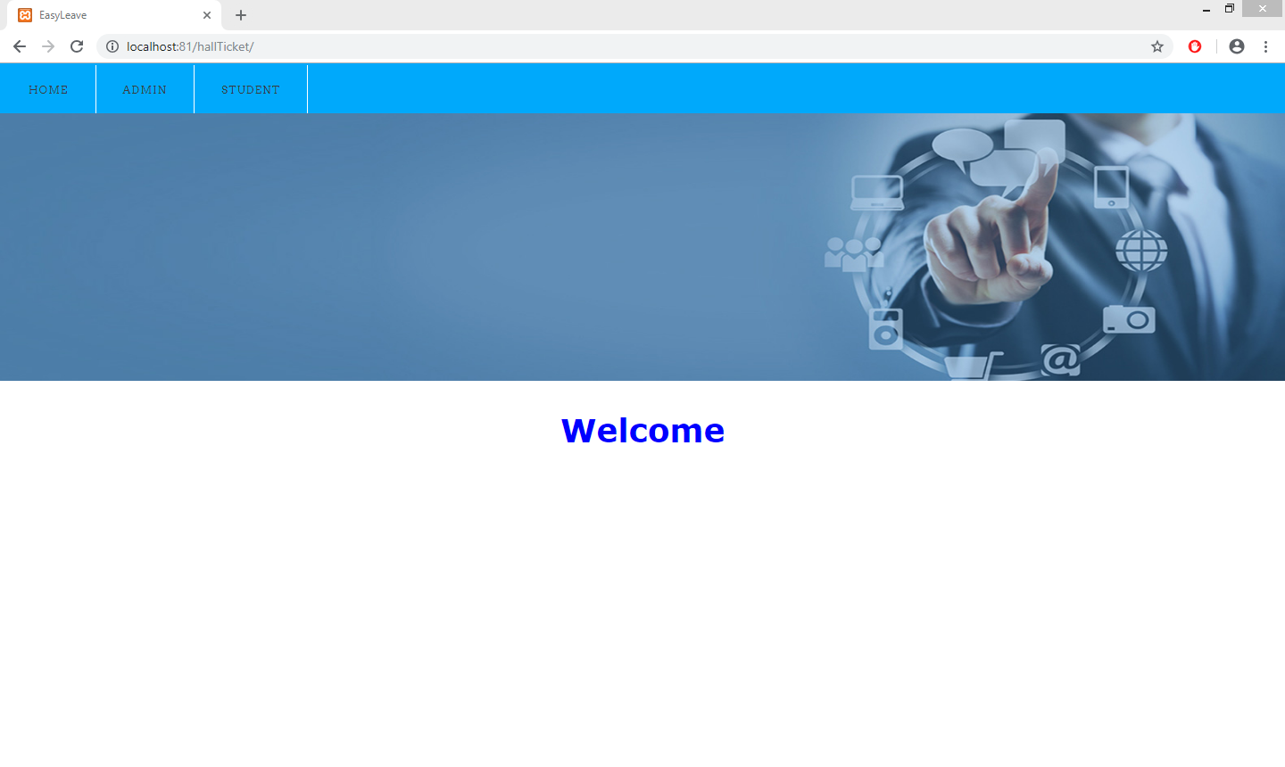

Admin Login:

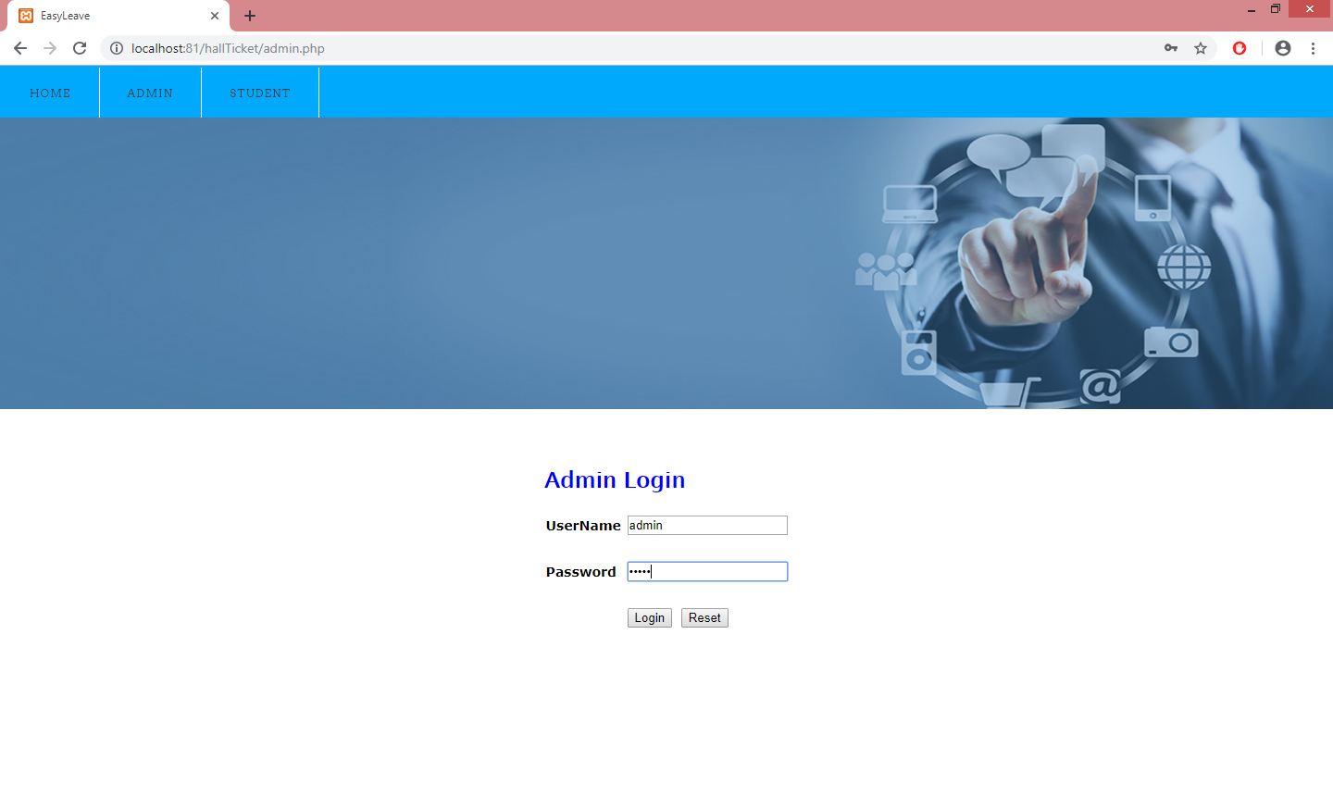

Admin Home Page:

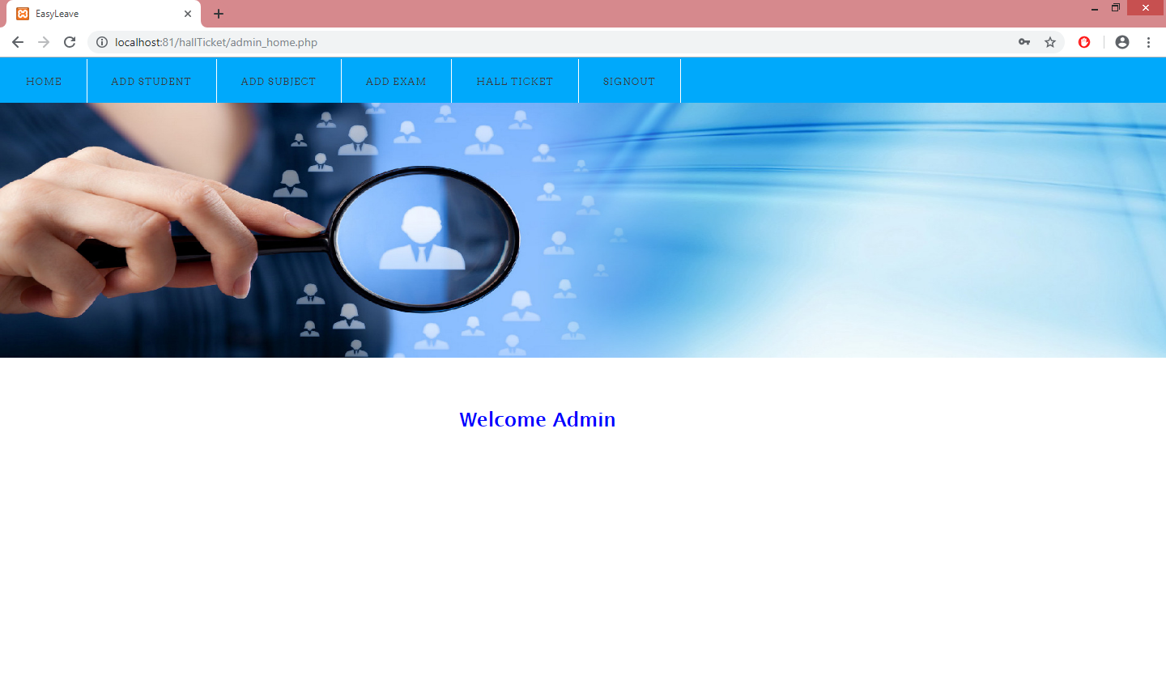

Student Details:

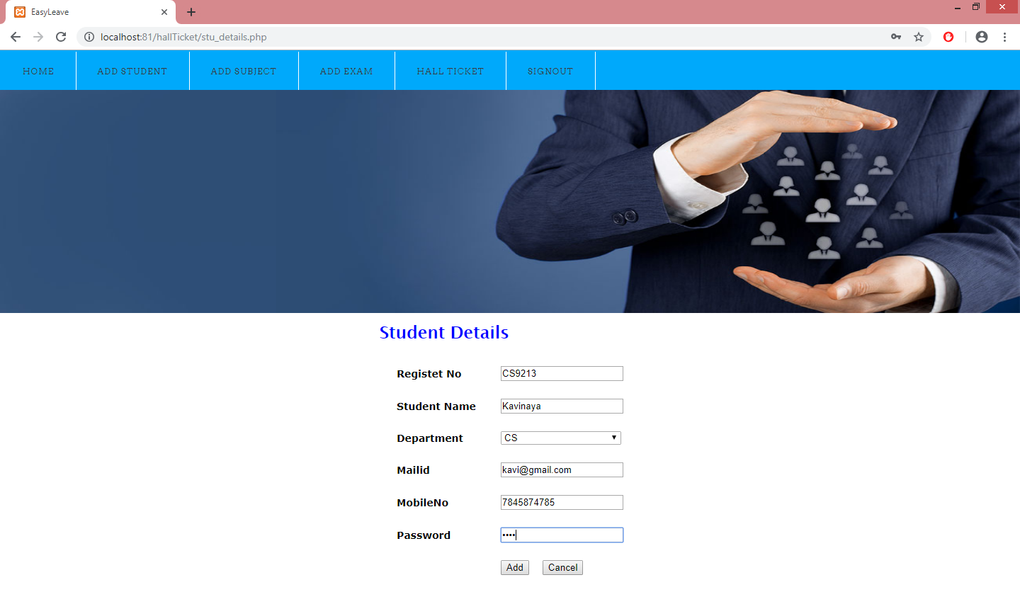

Add Subject Details:

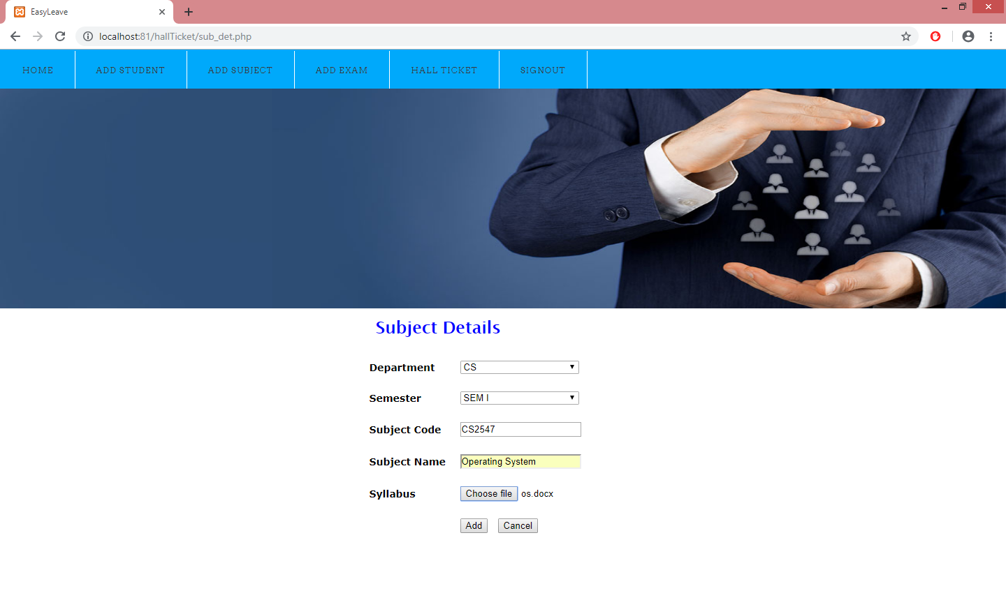

Add Exam Details:

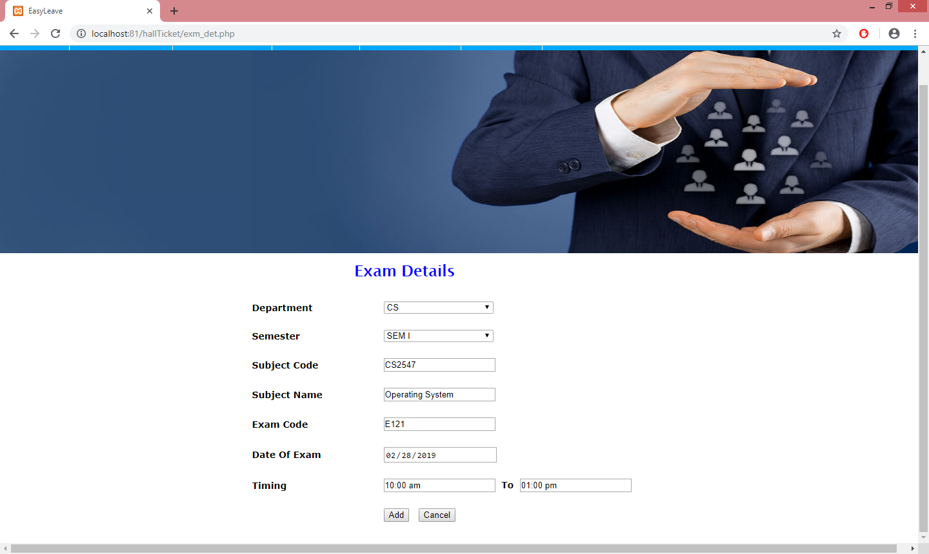

Admin Signout:

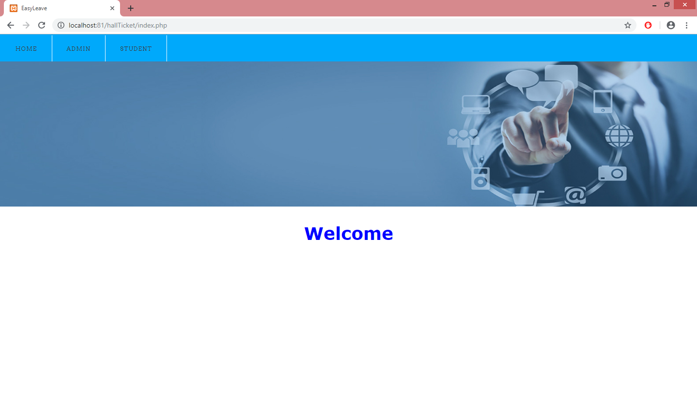

Student Login:

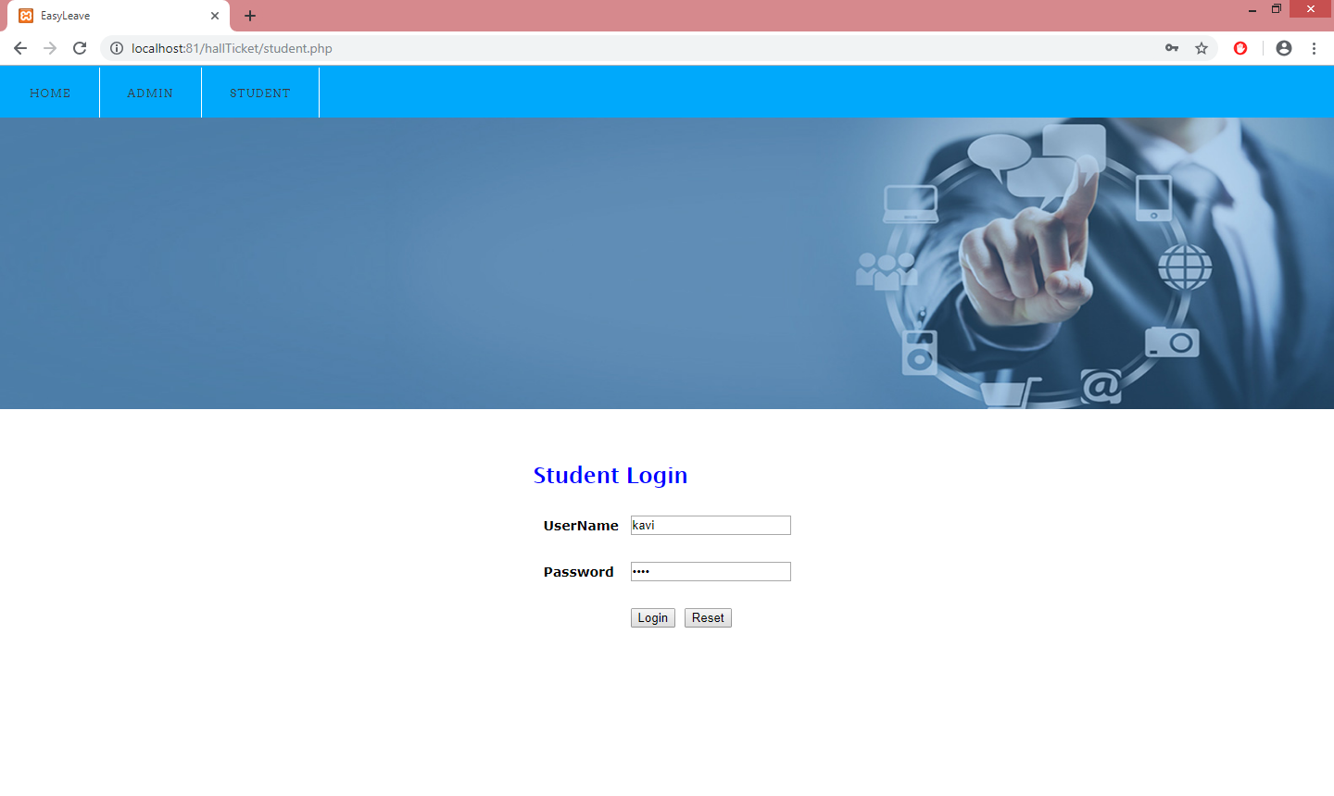

Student Home Page:

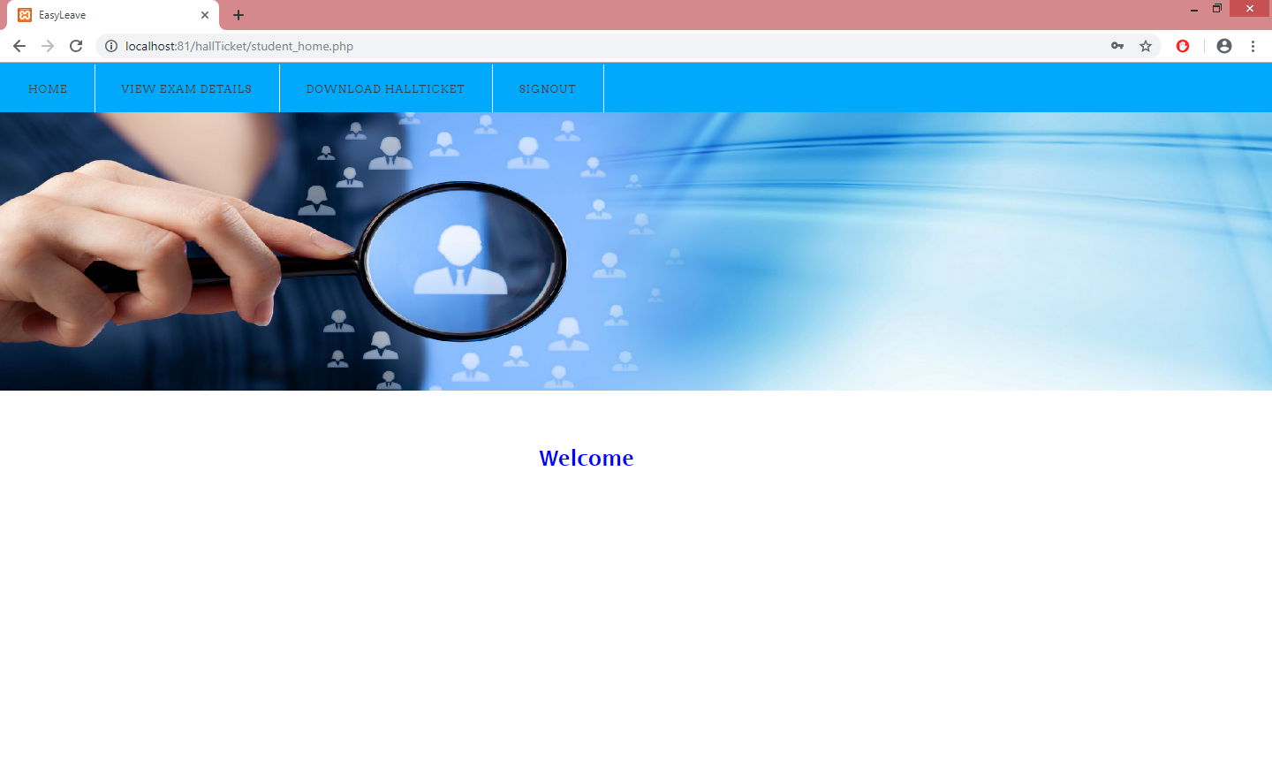

**SAMPLE OUTPUT SCREENS**

Generate And View Hall Ticket QR Code:

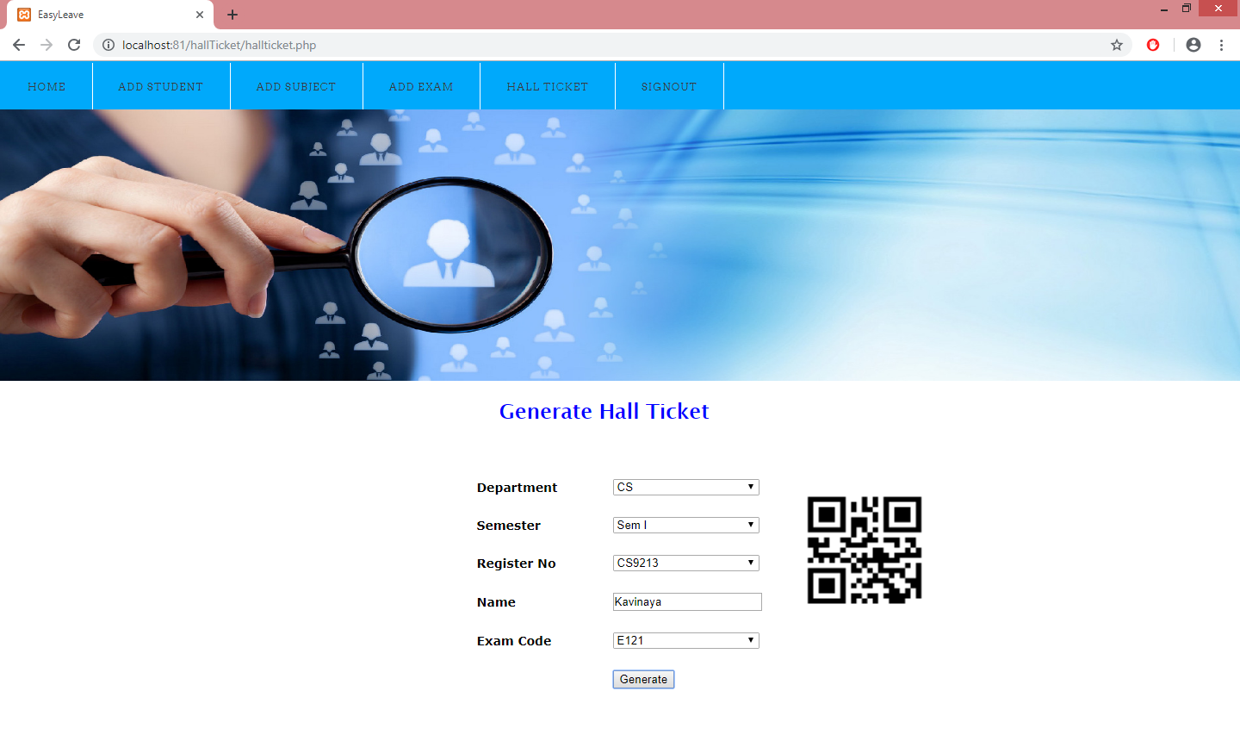

View Exam Details:

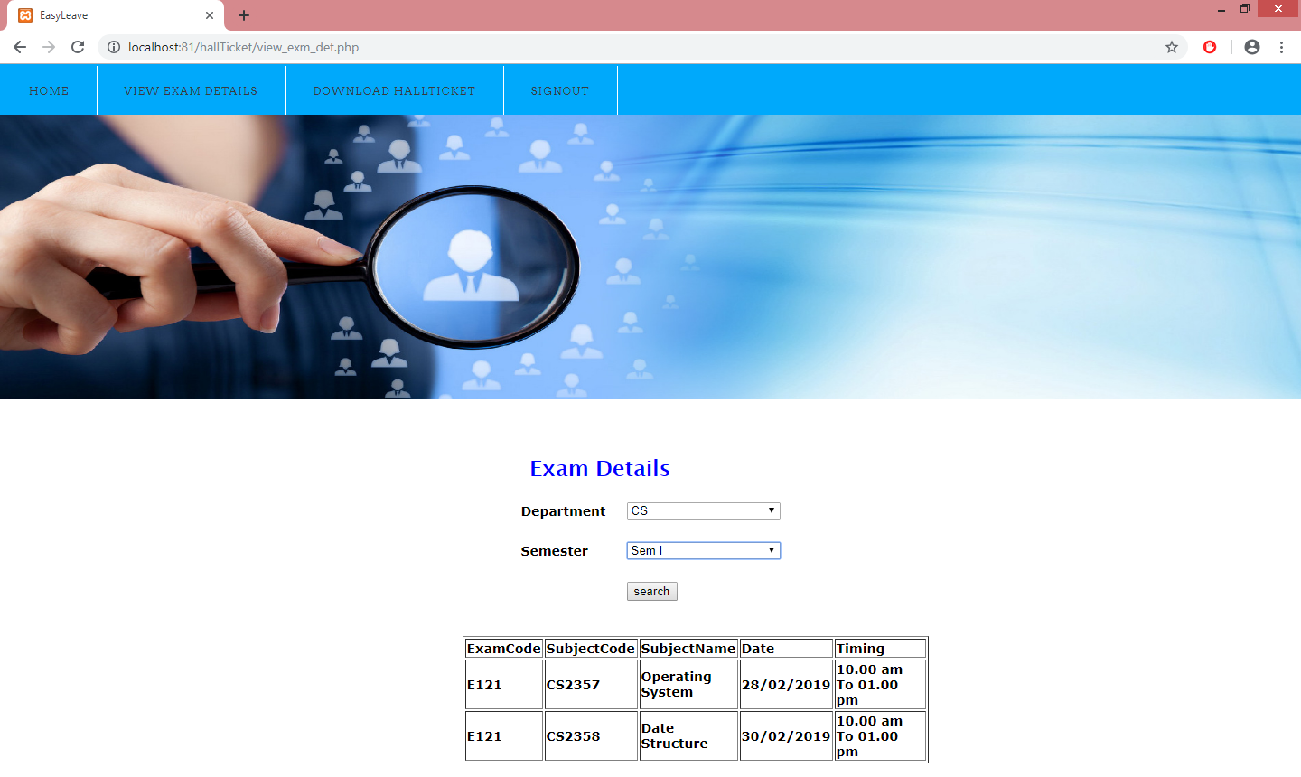

View And Download Hall Ticket QR code:

